Scenario 4: Statutory Tax Compliance & House Bank Setup
- SPRO—IMG—FINANCIAL ACCOUNTING—FINANCIAL ACCOUNTING FOR GLOBAL SETTING—WITHOILDING TAX—EXTENTED WITHOLDING TAX—CHECK REGION AND COUNTRY
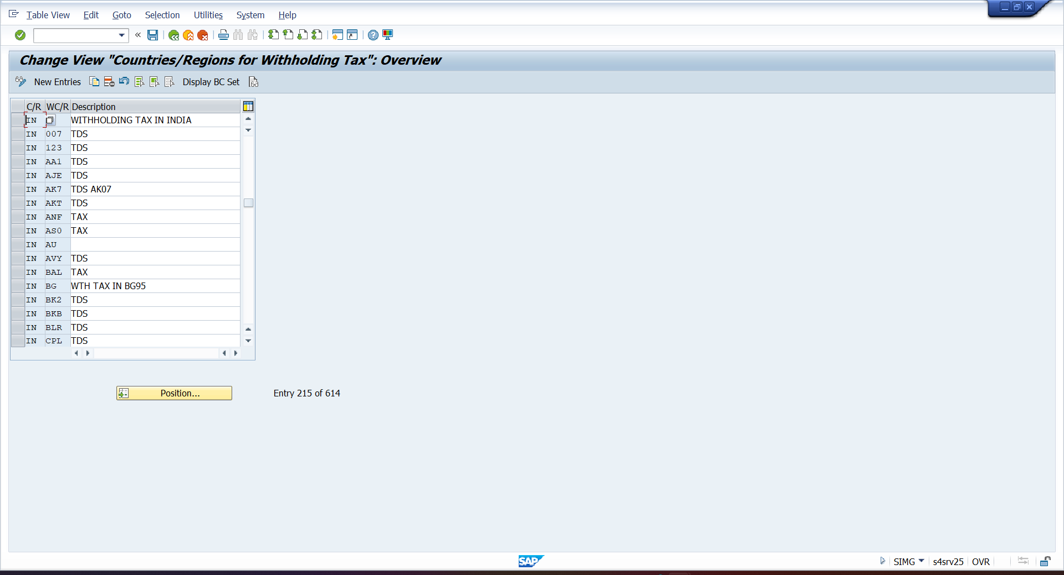
- SPRO—IMG—FINANCIAL ACCOUNTING—FINANCIAL ACCOUNTING FOR GLOBAL SETTING—WITHOILDING TAX—EXTENTED WITHOLDING TAX—TAX KEY
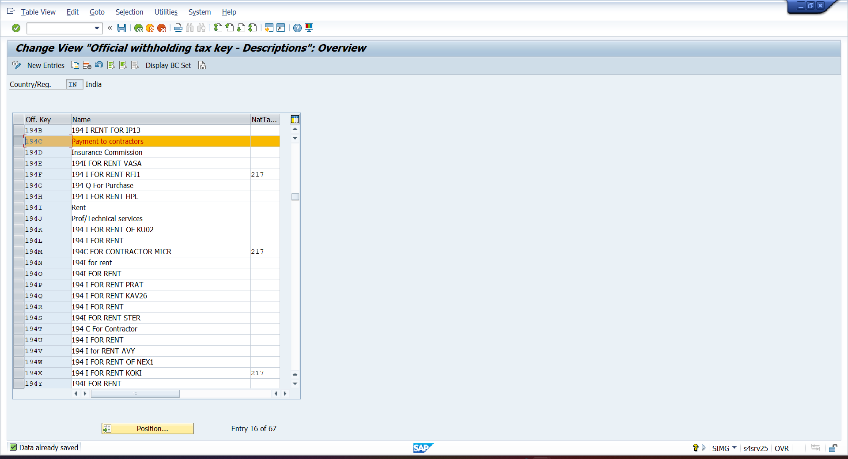

- SPRO—IMG—FINANCIAL ACCOUNTING—FINANCIAL ACCOUNTING FOR GLOBAL SETTING—WITHOILDING TAX—EXTENTED WITHOLDING TAX—REASON FOR EXCEPTION
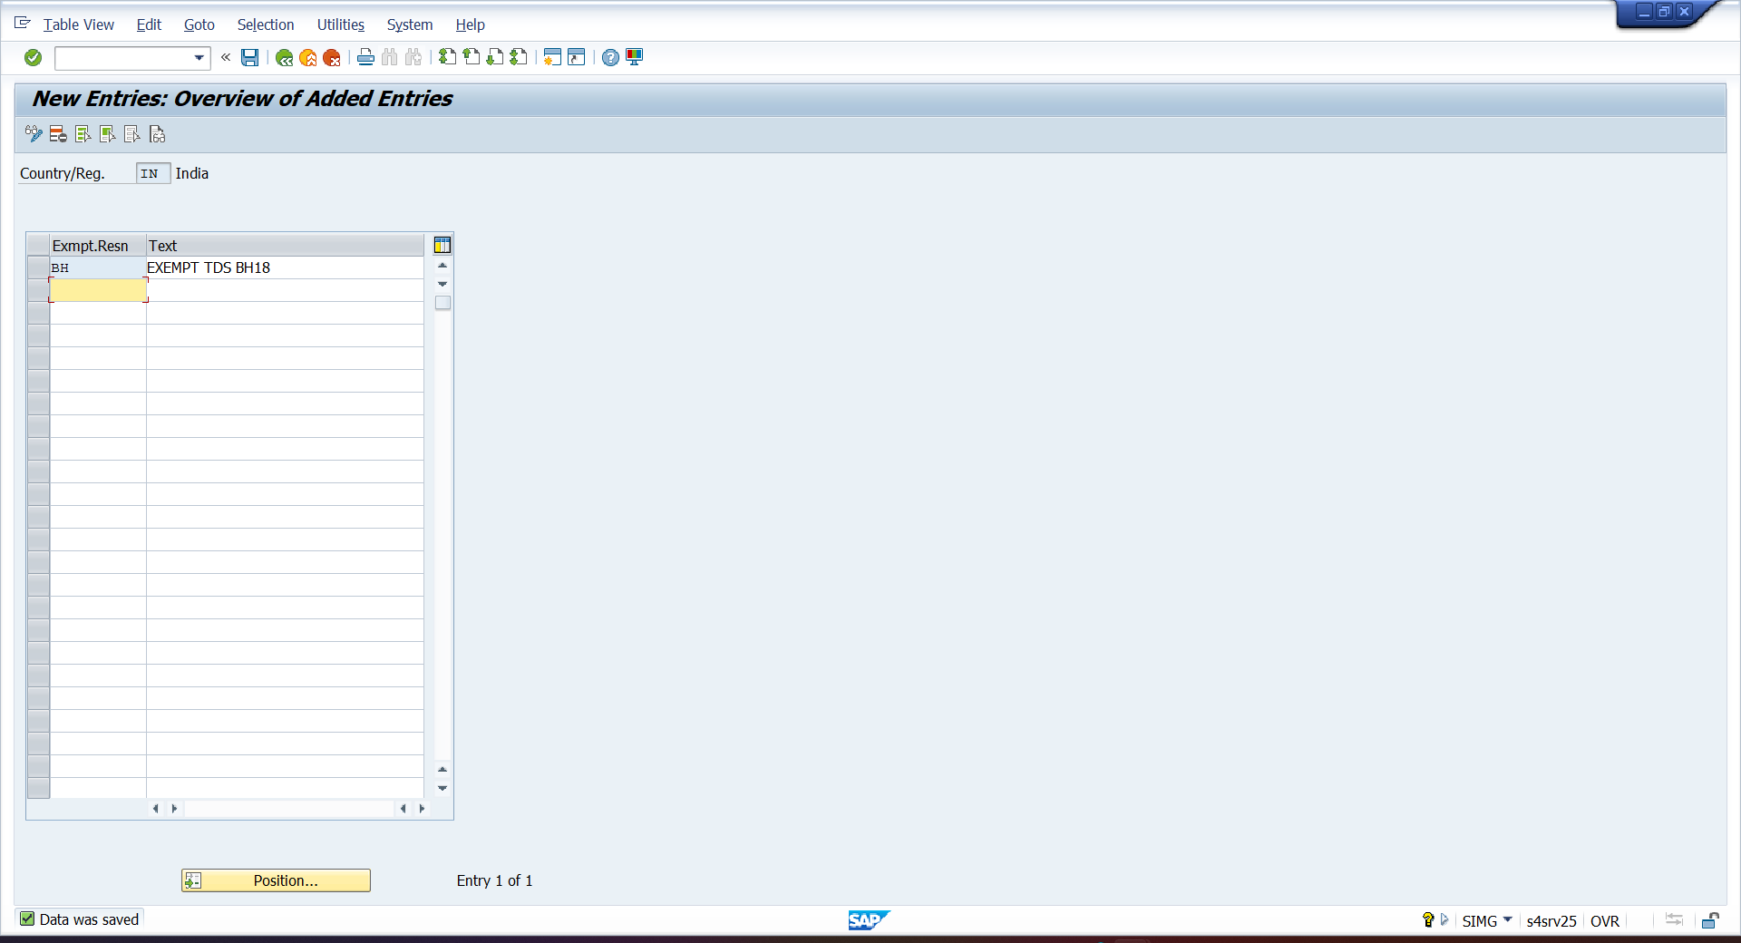
- SPRO—IMG—FINANCIAL ACCOUNTING—FINANCIAL ACCOUNTING FOR GLOBAL SETTING—WITHOILDING TAX—EXTENTED TAX—BASIC SETTING—CALCULATION—WITHOLDING TAX TYPE—INVOICE POSTING
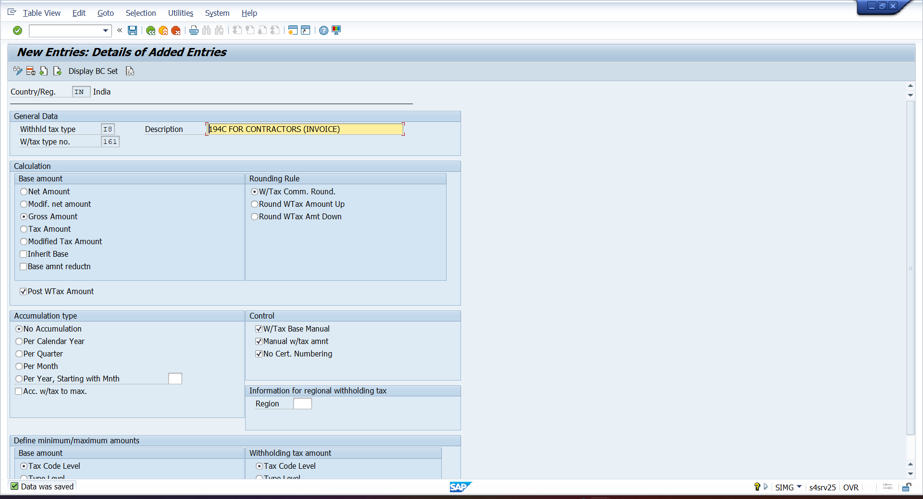

- SPRO—IMG—FINANCIAL ACCOUNTING—FINANCIAL ACCOUNTING FOR GLOBAL SETTING—WITHOILDING TAX—EXTENTED TAX—BASIC SETTING—CALCULATION—WITHOLDING TAX TYPE—PAYMENT POSTING
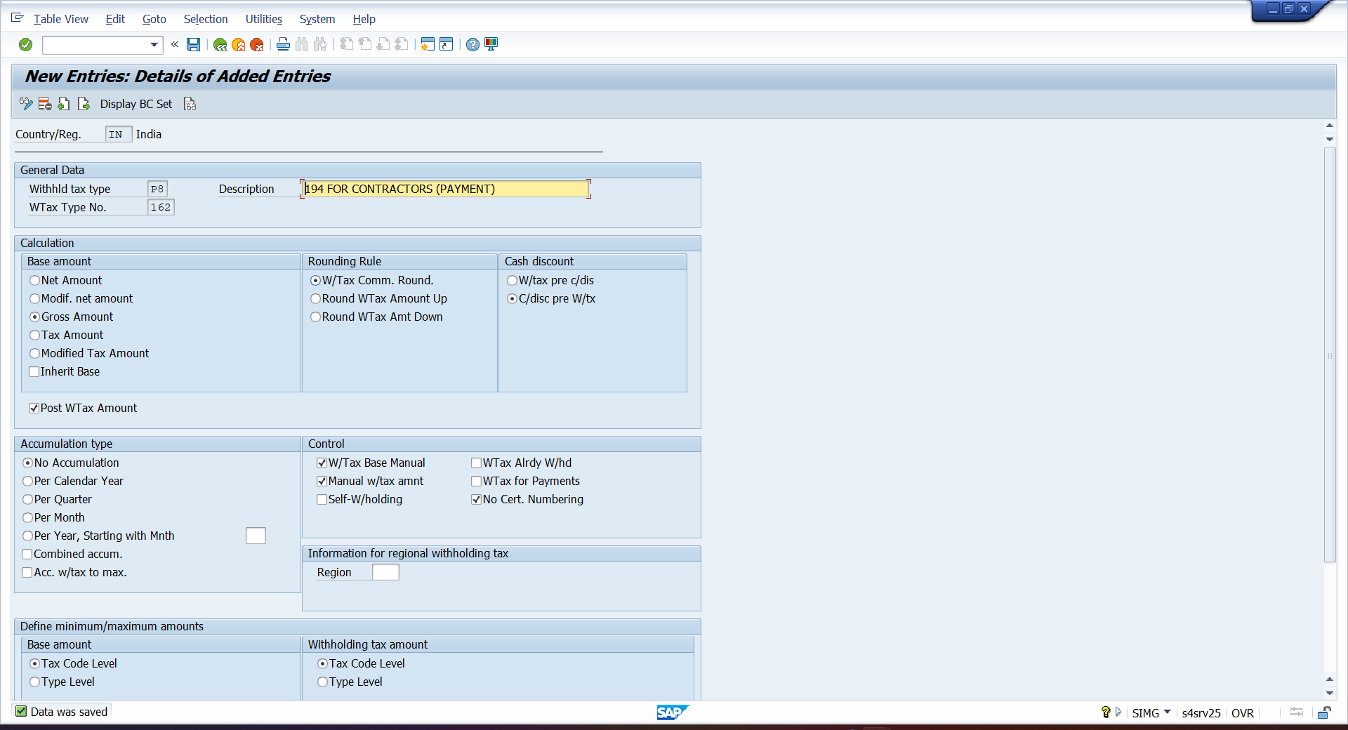
- SPRO—IMG—FINANCIAL ACCOUNTING—FINANCIAL ACCOUNTING FOR GLOBAL SETTING—WITHOILDING TAX—EXTENTED TAX—BASIC SETTING—RECEIPTENT TYPE
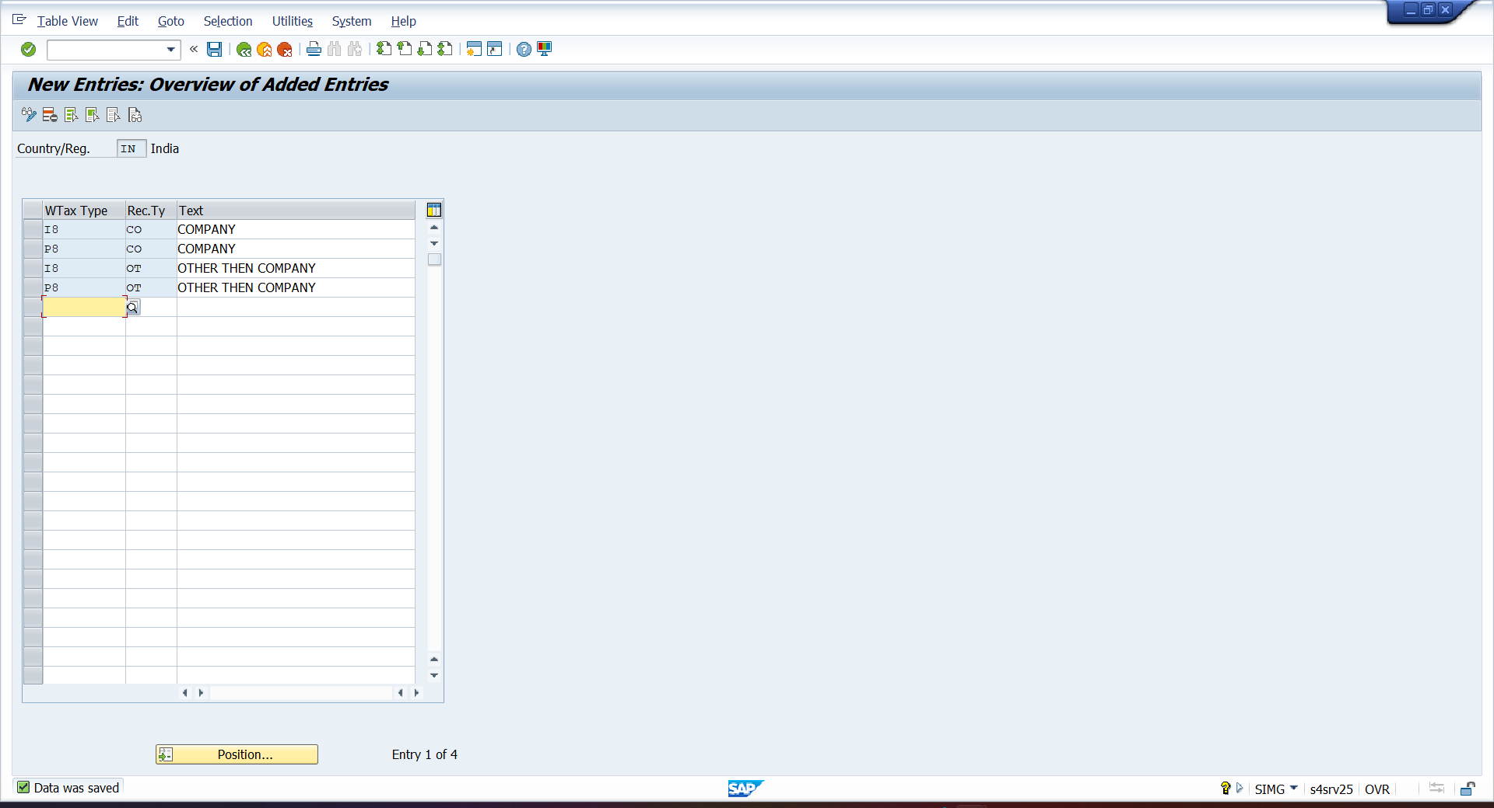

- SPRO—IMG—FINANCIAL ACCOUNTING—FINANCIAL ACCOUNTING FOR GLOBAL SETTING—WITHOILDING TAX—EXTENTED TAX—BASIC SETTING—INDIA—DEFINE BUSINESS PLACE
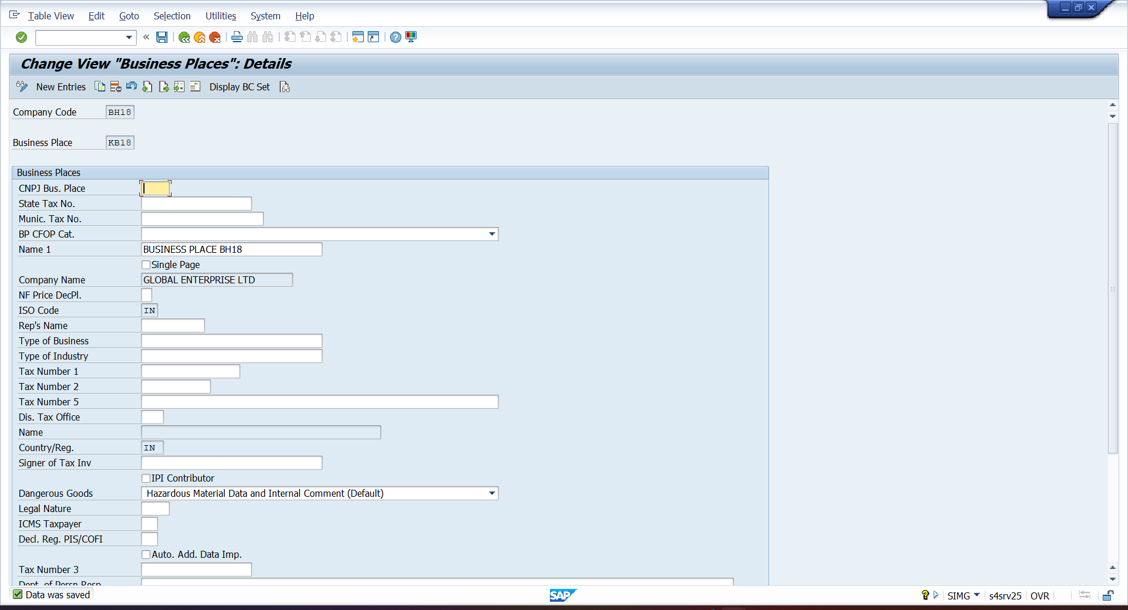
- SPRO—IMG—FINANCIAL ACCOUNTING—FINANCIAL ACCOUNTING FOR GLOBAL SETTING—WITHOILDING TAX—EXTENTED TAX—BASIC SETTING—INDIA—DEFINE SECTIONAL CODE FOR WITHOLDING TAX TYPE
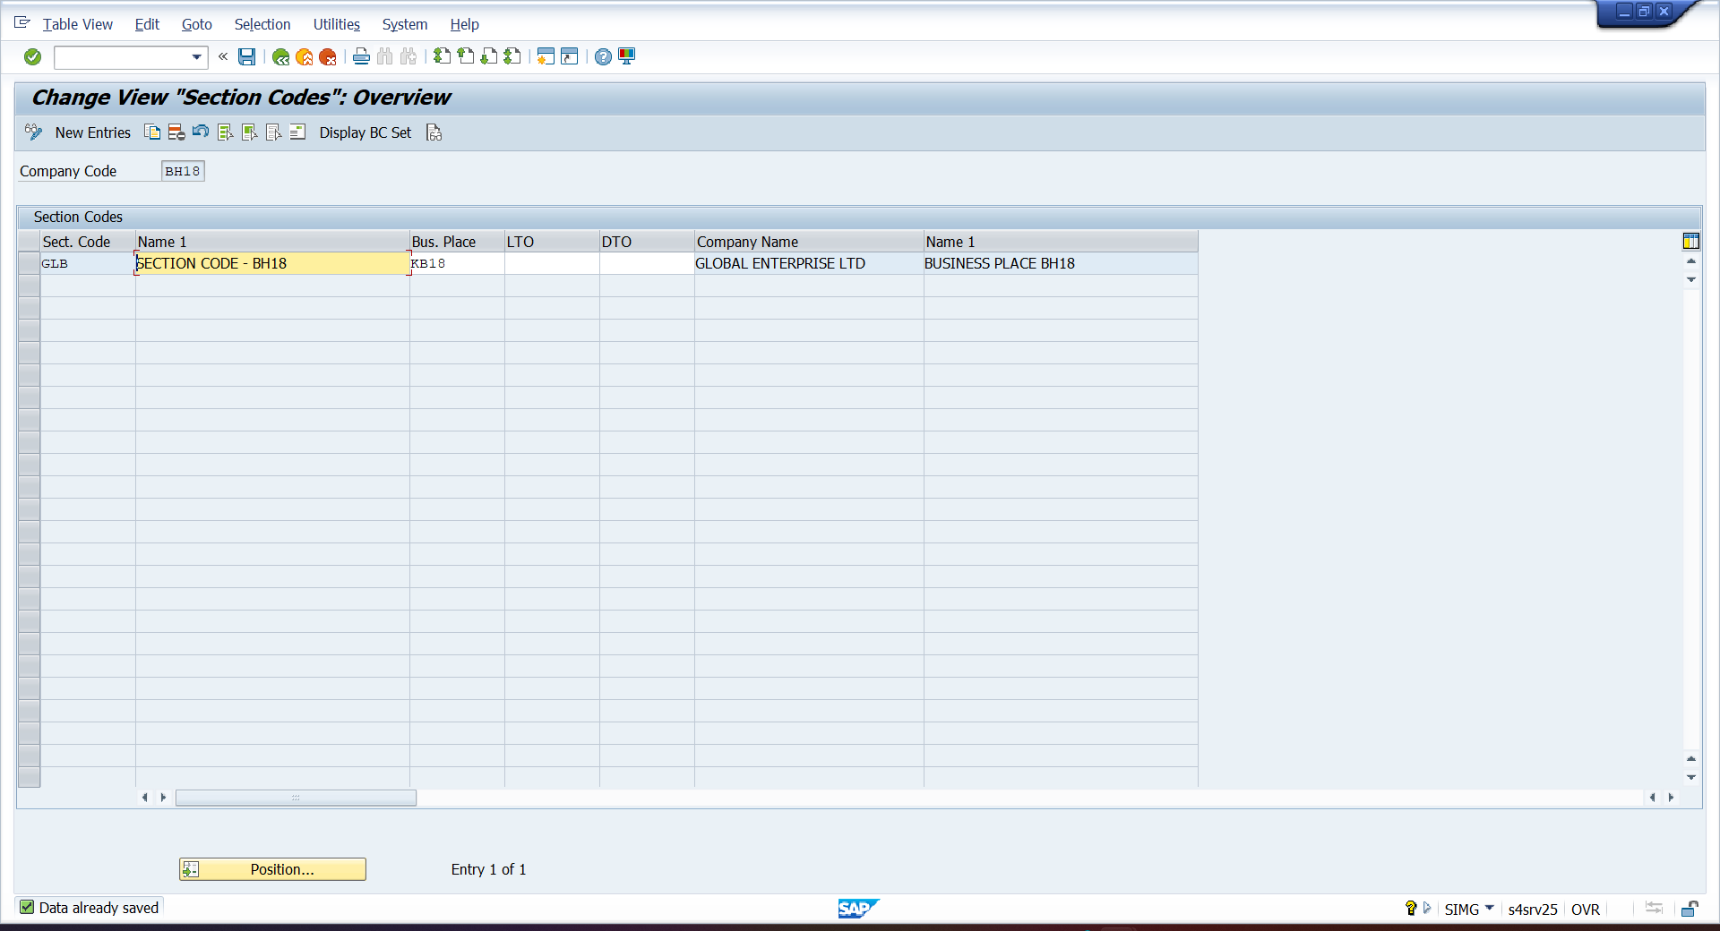

- SPRO—IMG—FINANCIAL ACCOUNTING—FINANCIAL ACCOUNTING FOR GLOBAL SETTING—WITHOILDING TAX—CALCULATION—EXCHANGE RATE TYPE FOR WITHHOLDING TAX
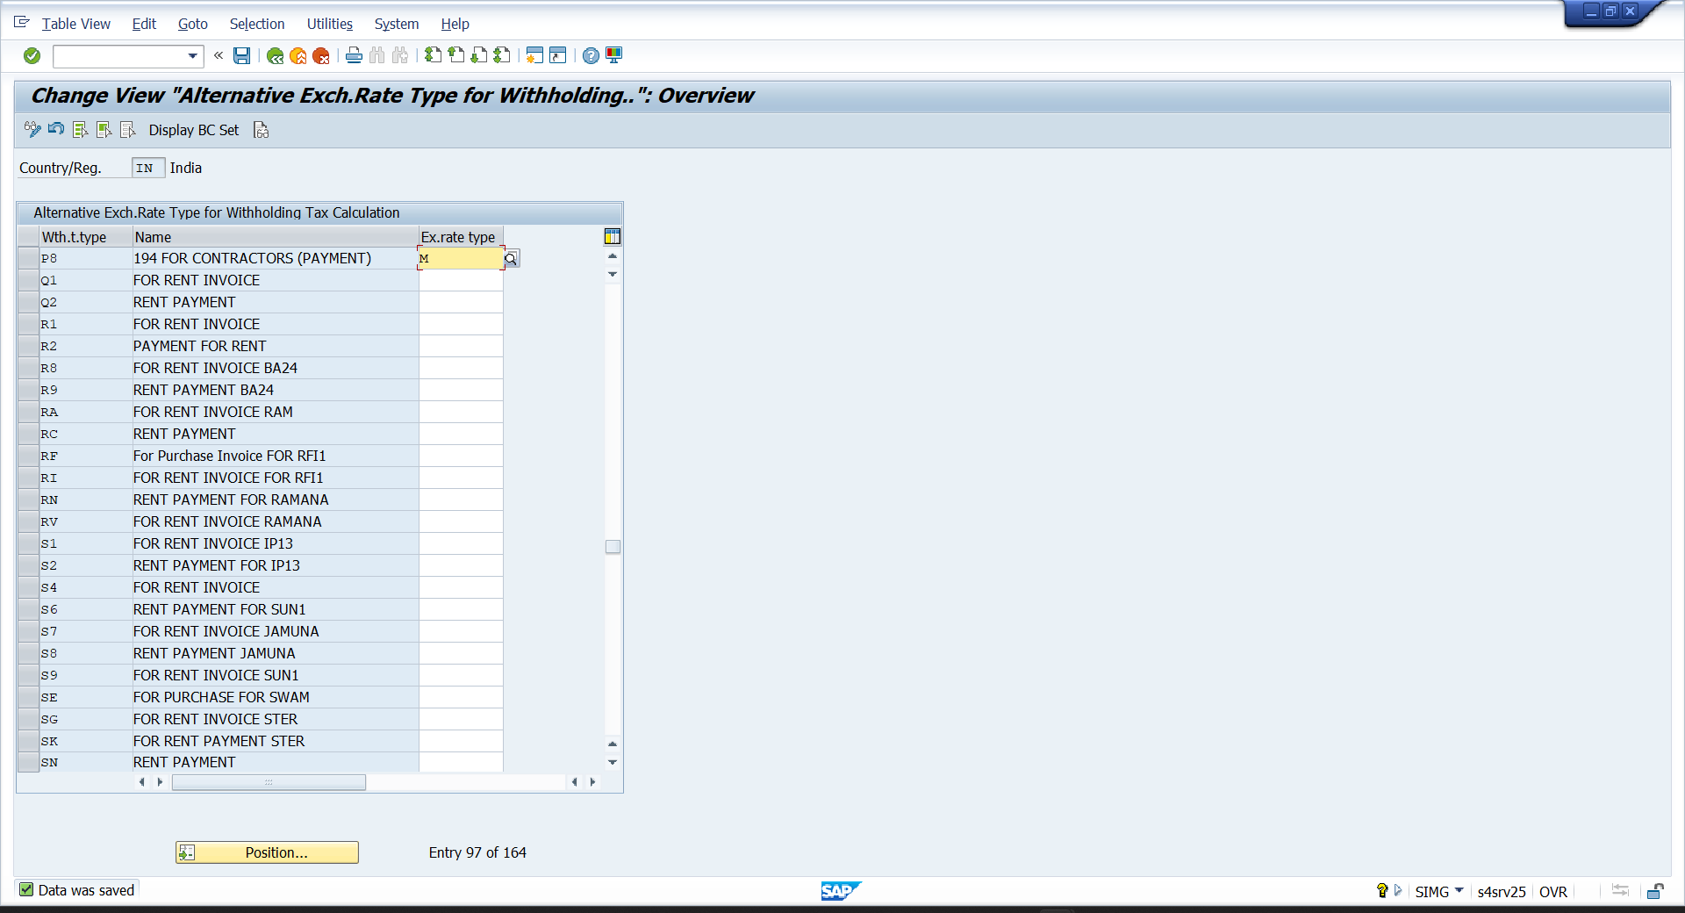

- SPRO—IMG—FINANCIAL ACCOUNTING—FINANCIAL ACCOUNTING FOR GLOBAL SETTING—WITHOILDING TAX—CALCULATION—ROUNDING RULES
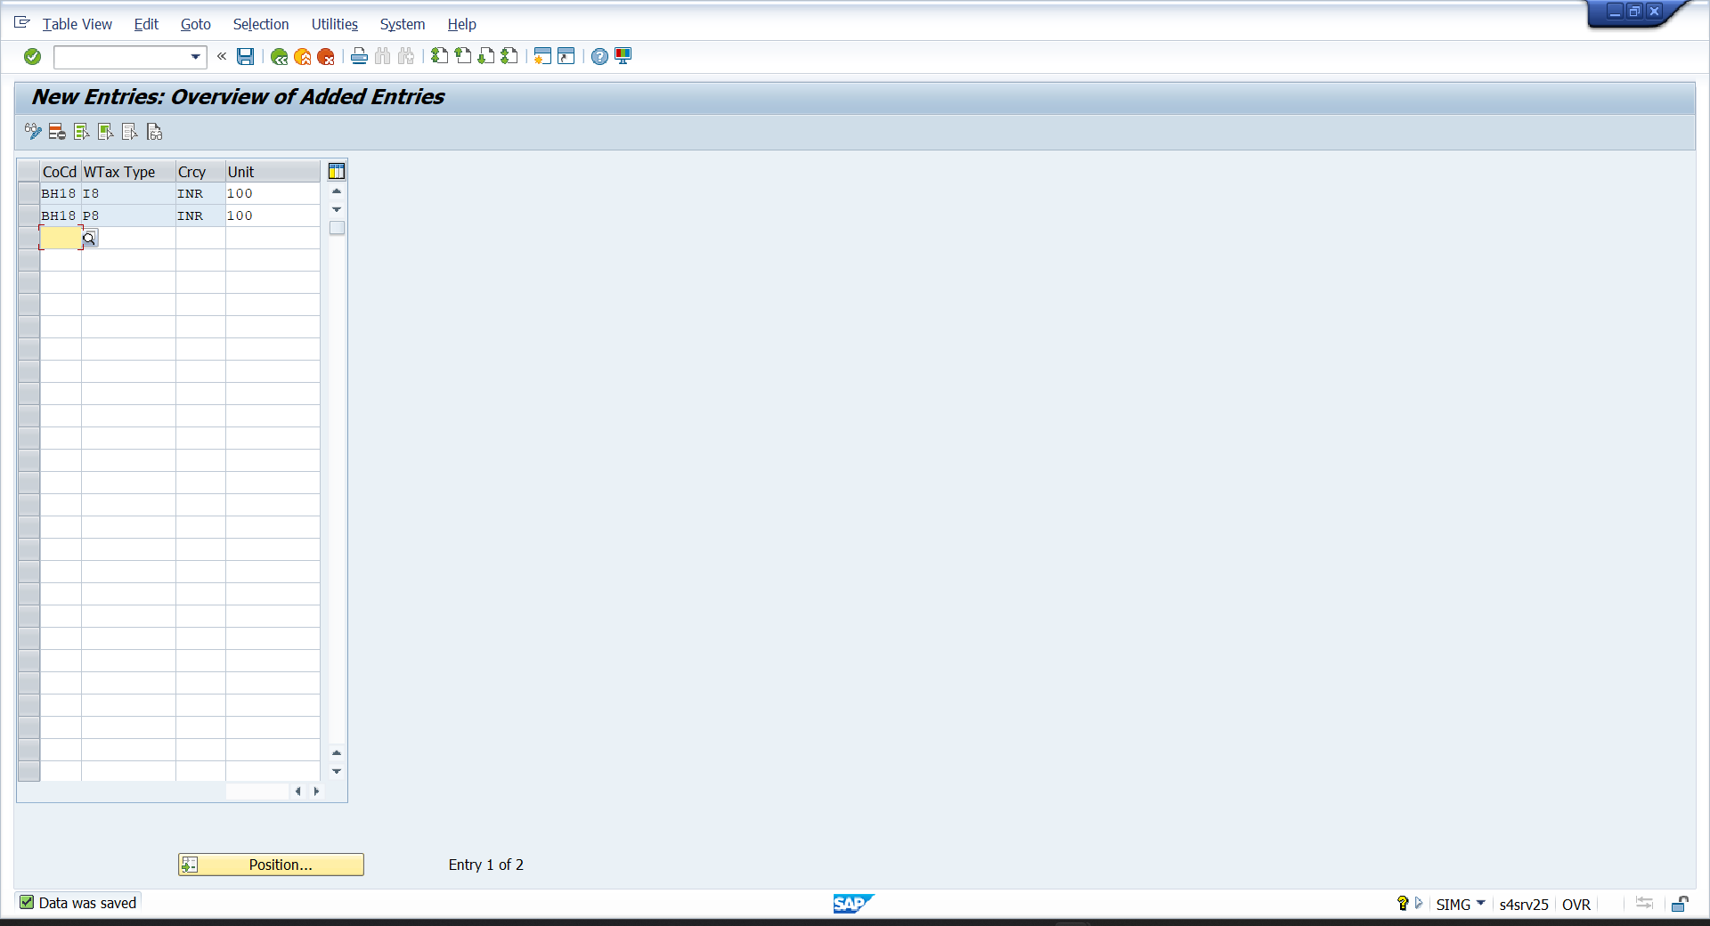

- SPRO—IMG—FINANCIAL ACCOUNTING—FINANCIAL ACCOUNTING FOR GLOBAL SETTING—WITHOILDING TAX—CALCULATION—WITHHOLDING TAX CODE—DEFINE TAX CODE
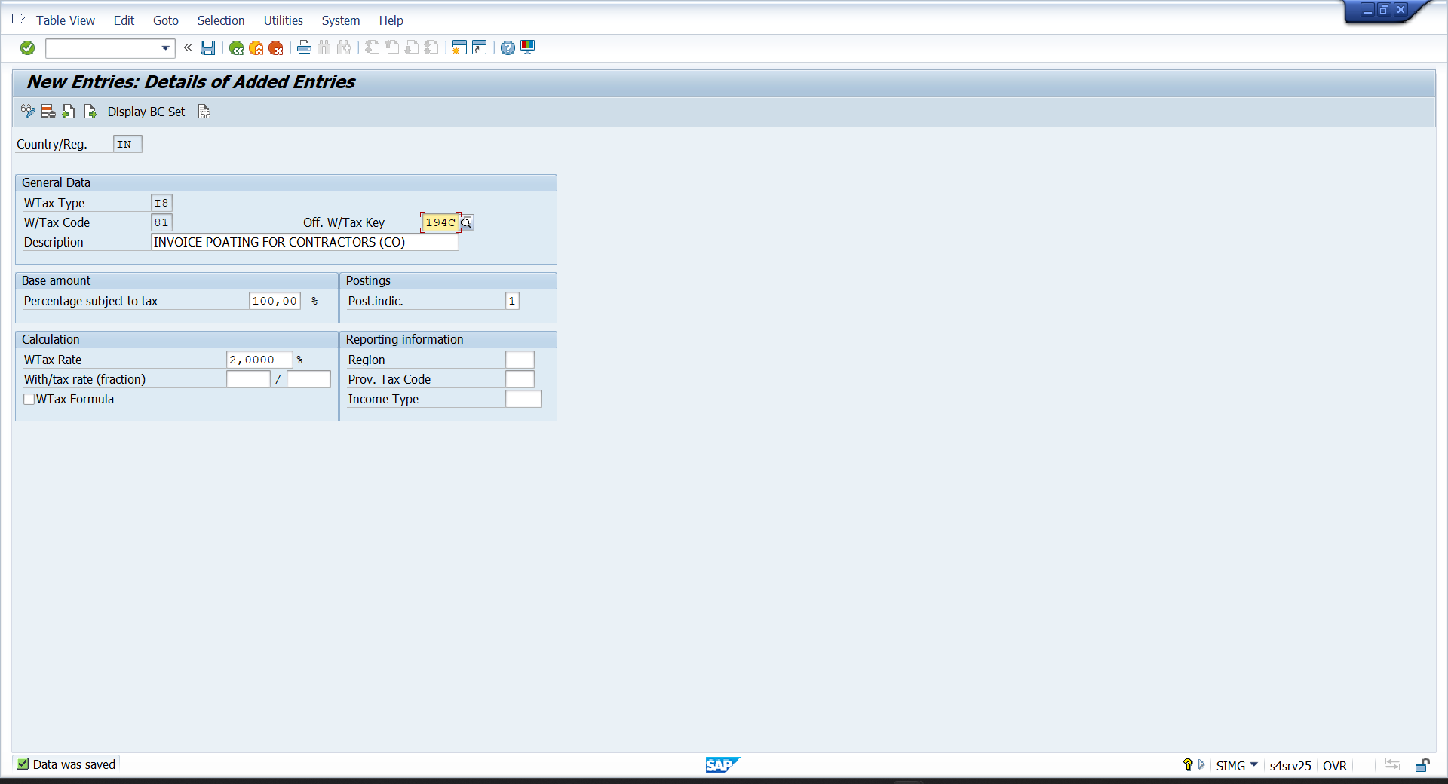

- SPRO—IMG—FINANCIAL ACCOUNTING—FINANCIAL ACCOUNTING FOR GLOBAL SETTING—WITHOILDING TAX-- CALCULATION—WITHHOLDING TAX CODE—DEFINE TAX CODE
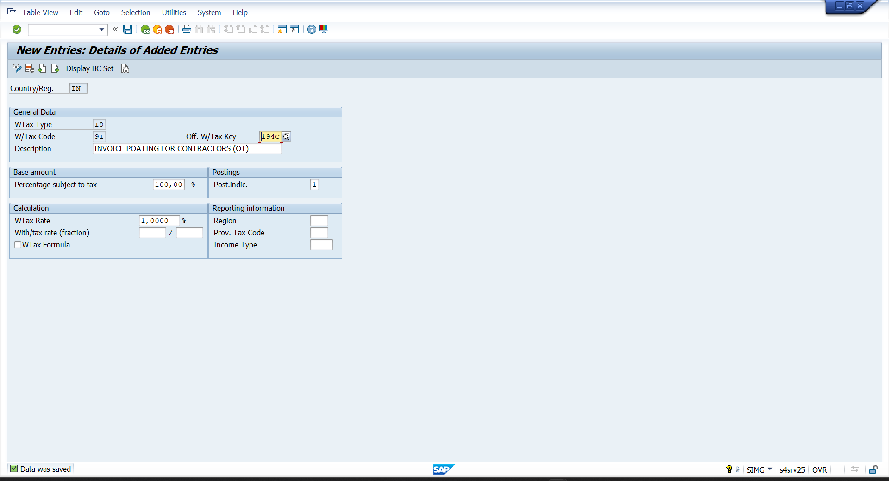

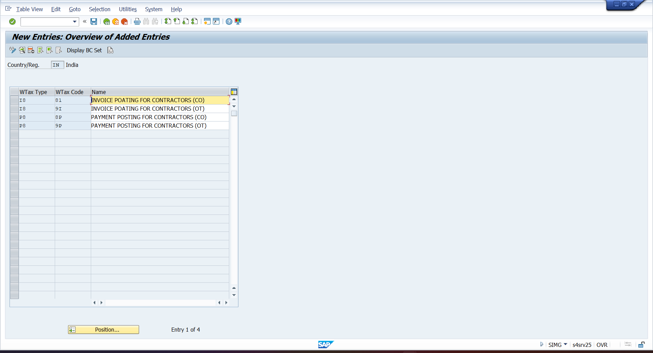

- SPRO—IMG—FINANCIAL ACCOUNTING—FINANCIAL ACCOUNTING FOR GLOBAL SETTING—WITHOILDING TAX—EXTENTED WITHHOLDING TAX—COMPANY CODE—ASSIGN WITHHOLDING TAX TYPE TO CO.CODE
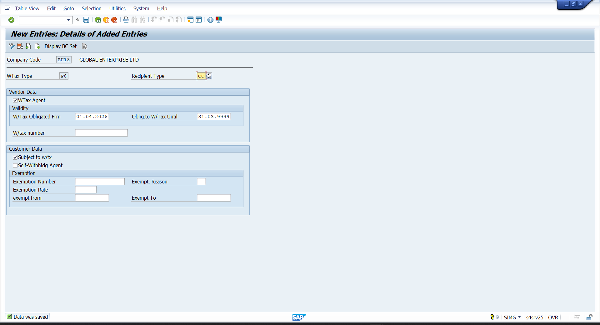

- FS00
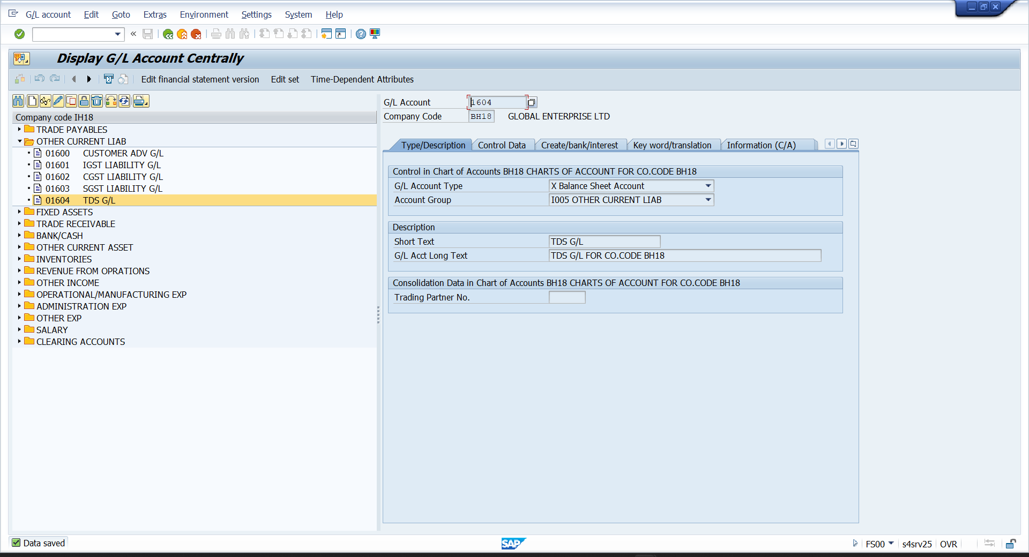
- SPRO—IMG—FINANCIAL ACCOUNTING—FINANCIAL ACCOUNTING FOR GLOBAL SETTING—WITHOILDING TAX—EXTENTED WITHHOLDING TAX—POSTING—ACCOUNT FOE WHT—DEFINE ACCOUNT FOR WITHHOLDING TAX TO BE PAID OVER
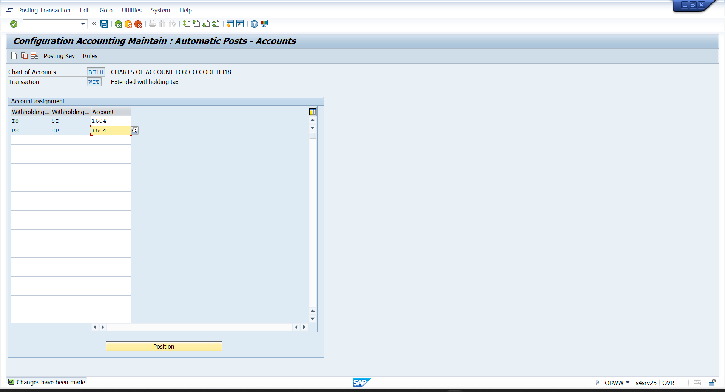

- SPRO—IMG—FINANCIAL ACCOUNTING—FINANCIAL ACCOUNTING FOR GLOBAL SETTING—WITHOILDING TAX—EXTENTED TAX—INFLATION ACCOUNTING—ASSIGNMENT TO INFLATION—MAINTAION FSV
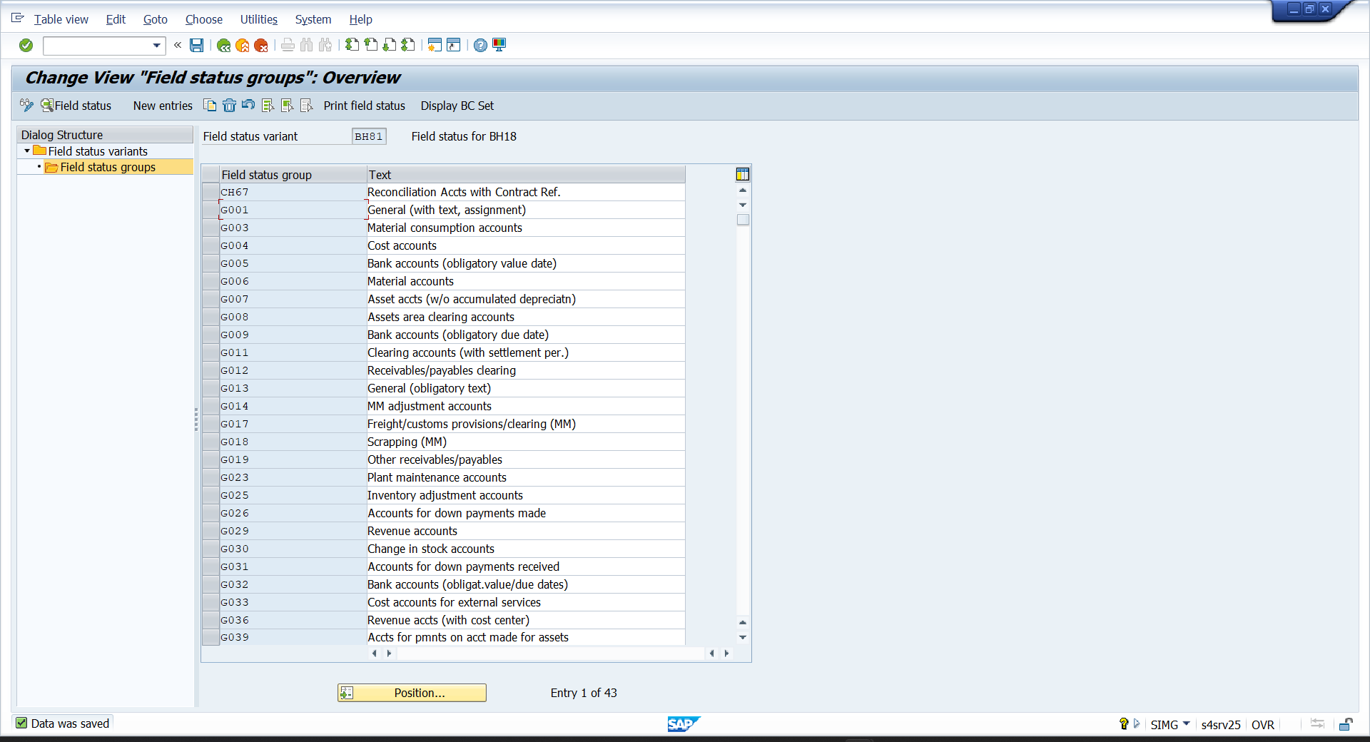

- SPRO—IMG – FNANCIAL ACCOUNTING—LOGISTIC(GENERAL)—TAX ON GOOD MOVEMENT—INDIA—BASIC SETTING—MAINTIAON COPY CODE SETTING
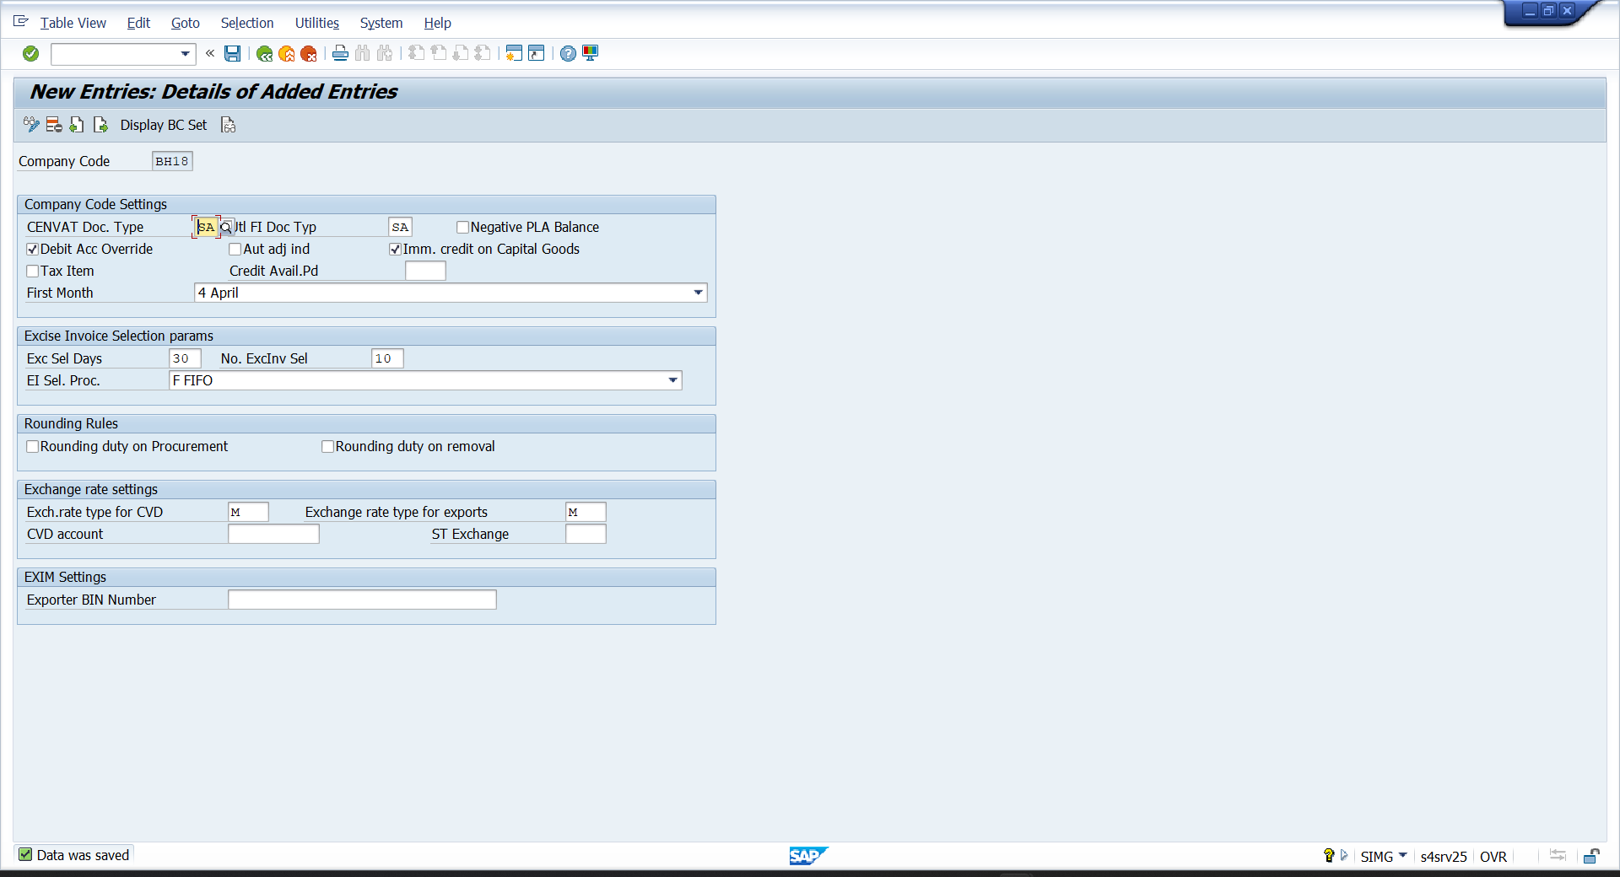

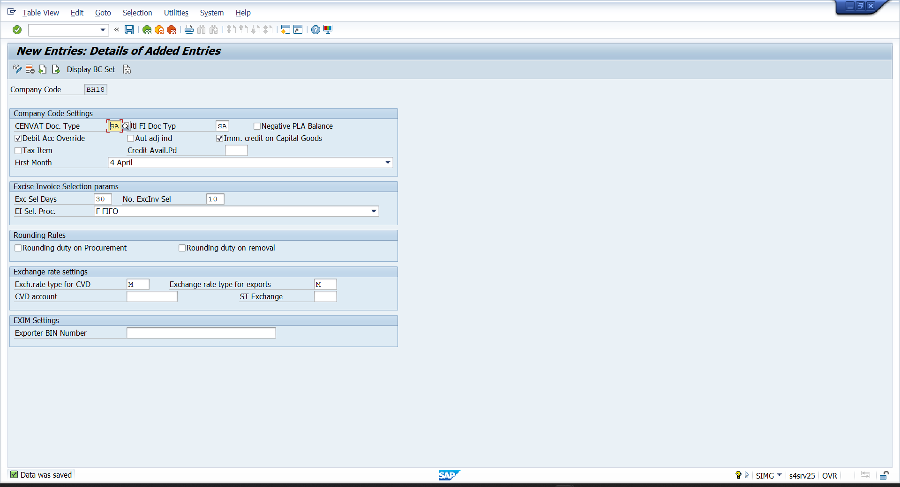
- SPRO—IMG—FINANCIAL ACCOUNTING—FINANCIAL ACCOUNTING FOR GLOBAL SETTING—WITHOILDING TAX—EXTENTED TAX—CALCULATIONS—WITHHOLDING TAX CODE—DEFINE FORMULA FOR WITHHOLDING TAX CODE
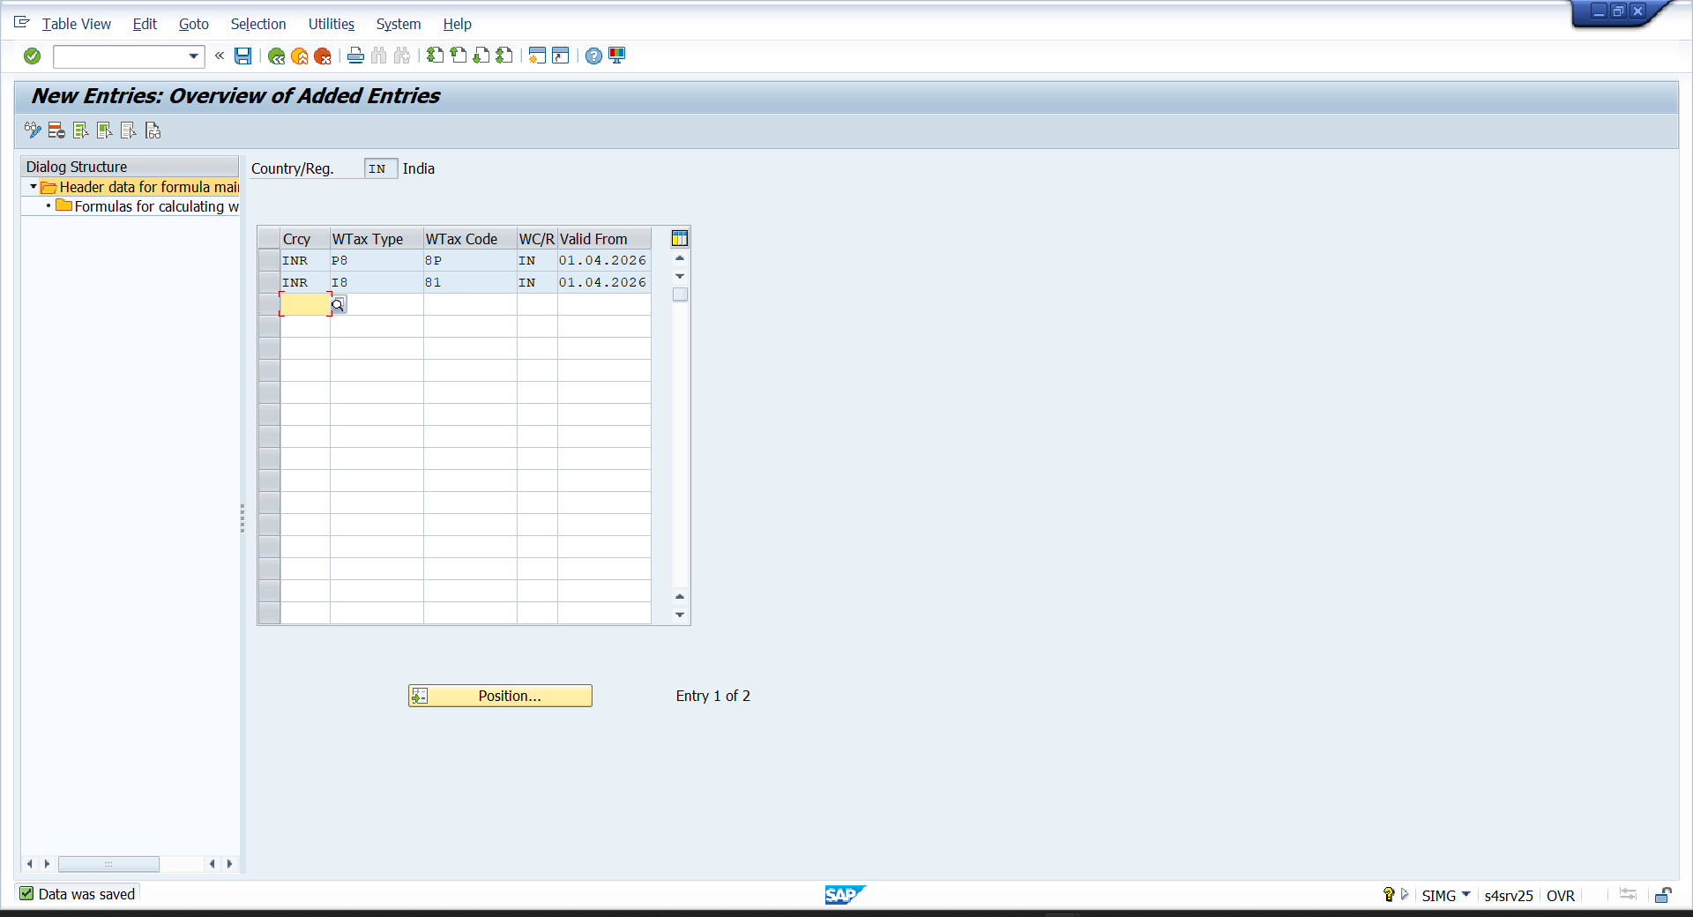

- SPRO—IMG—FINANCIAL ACCOUNTING—FINANCIAL ACCOUNTING FOR GLOBAL SETTING—WITHOILDING TAX—EXTENTED TAX—POSTING—INDIA—TAX COLLECTED AT SOURCE—ASSIGN BUSINESS PLACE TO SECTIONAL CODE
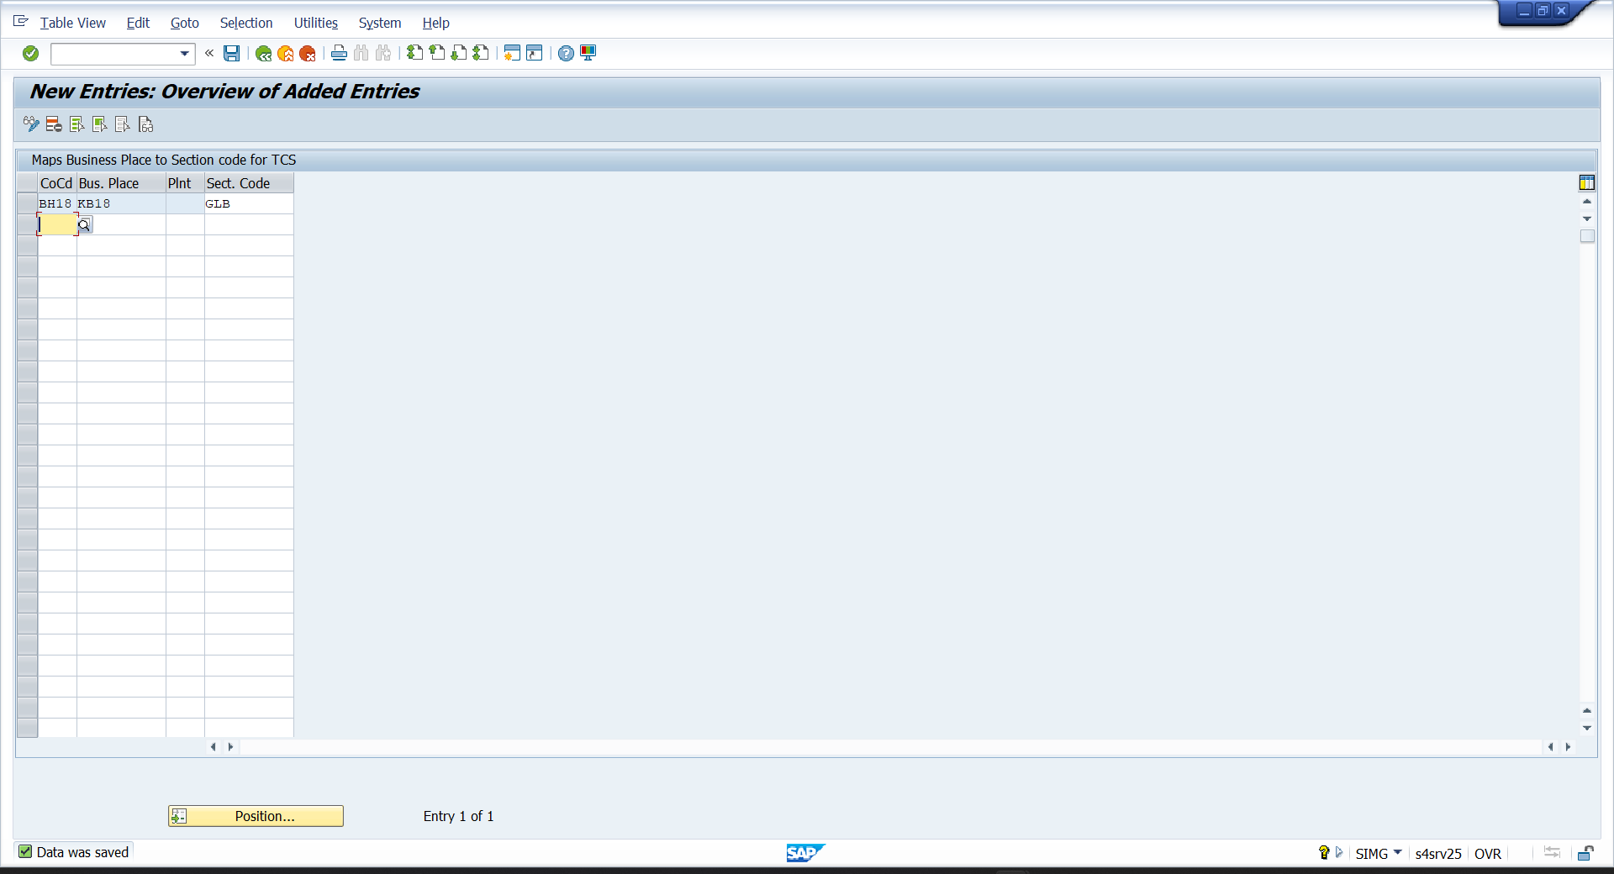
- SPRO—IMG—FINANCIAL ACCOUNTING—FINANCIAL ACCOUNTING FOR GLOBAL SETTING—WITHOILDING TAX—EXTENTED TAX—POSTING—INDIA—REMITTANCE CHALLANS—MAINTAIN NUMBER RANGES FOR REMITTANCE CHALLAN
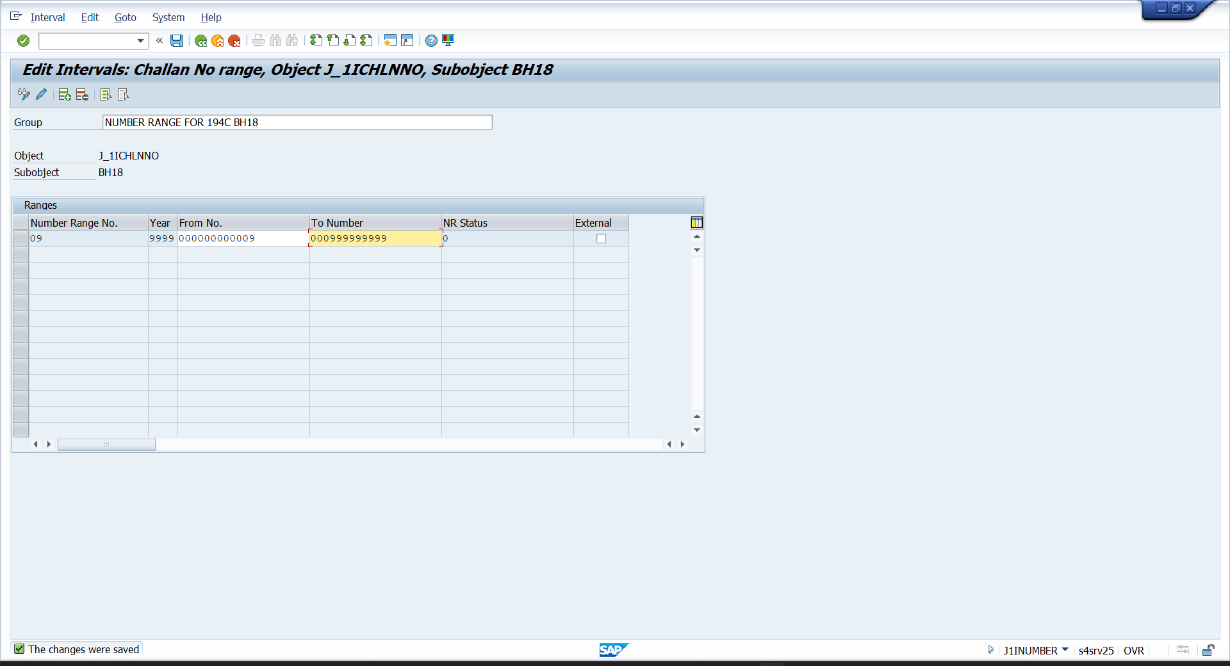

- SPRO—IMG—FINANCIAL ACCOUNTING—FINANCIAL ACCOUNTING FOR GLOBAL SETTING—WITHOILDING TAX—EXTENTED TAX—POSTING—INDIA— REMITTANCE CHALLANS—MAINTAIN NUMBER GROUP FOR REMITTANCE CHALLAN
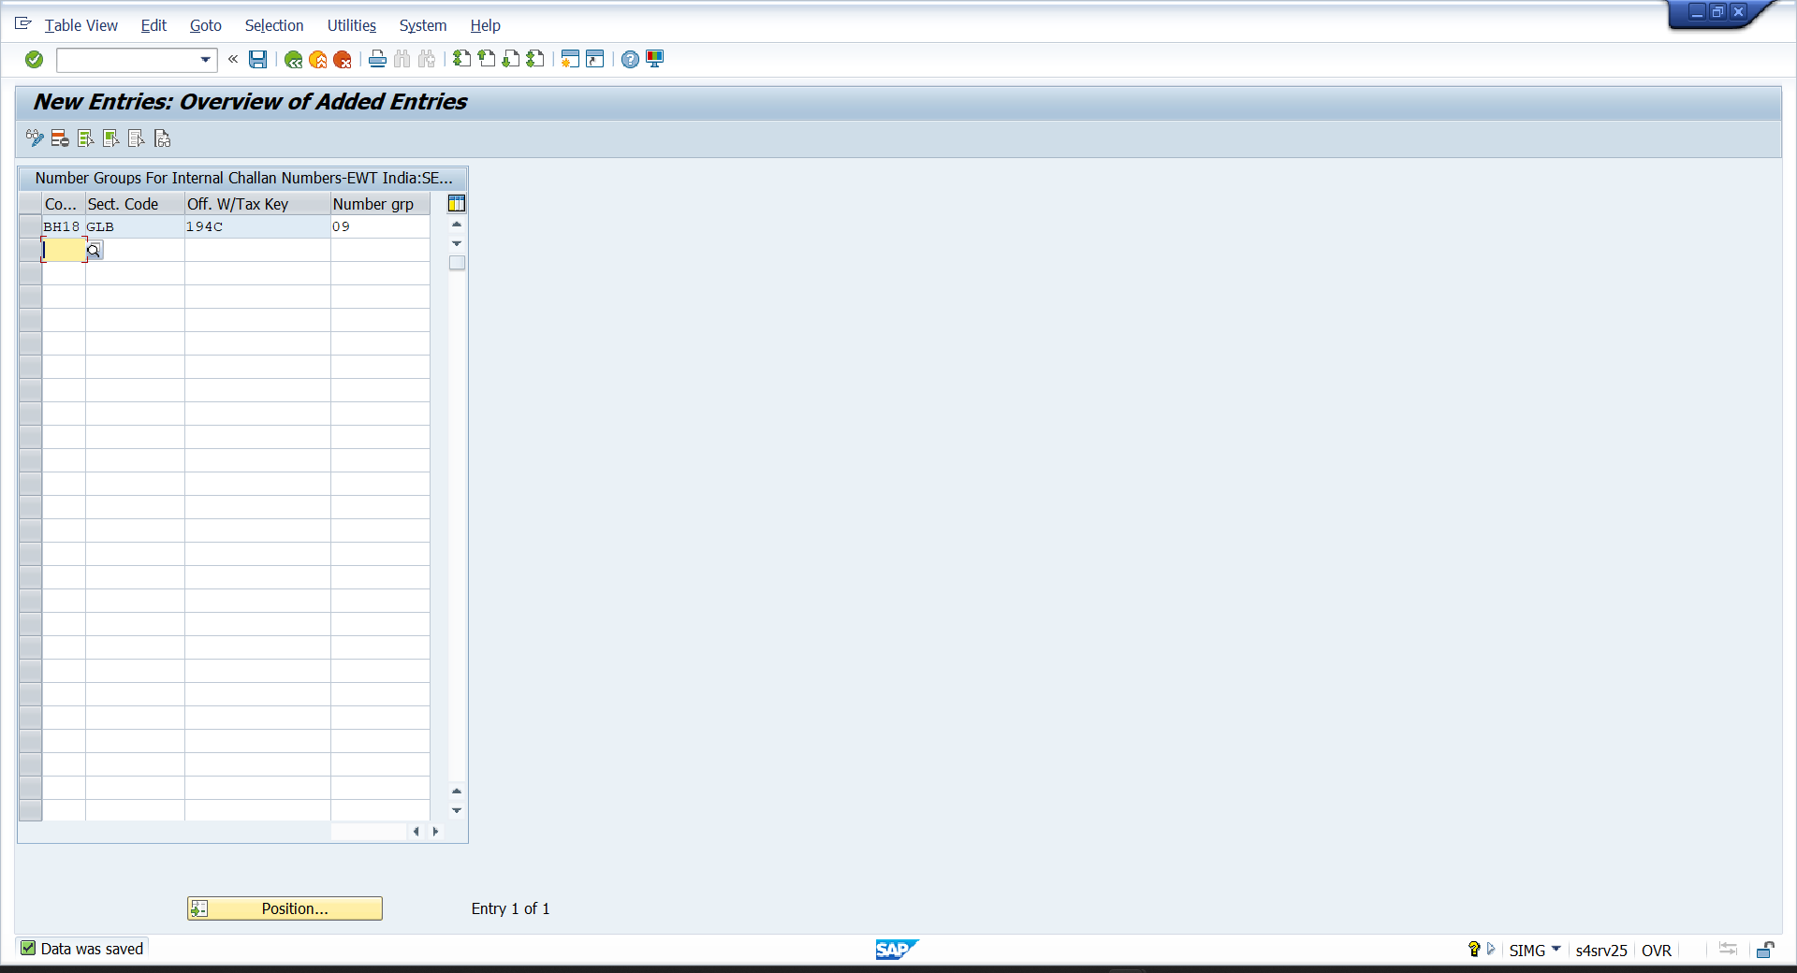
- SPRO—IMG—FINANCIAL ACCOUNTING—FINANCIAL ACCOUNTING FOR GLOBAL SETTING—WITHOILDING TAX—EXTENTED TAX—POSTING—INDIA— REMITTANCE CHALLANS—ASSIGN NUMBER RANGE TO NO. GROUP
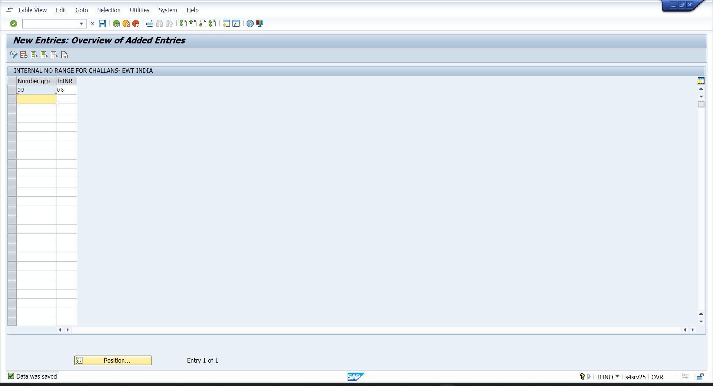

- SPRO—IMG—FINANCIAL ACCOUNTING—FINANCIAL ACCOUNTING FOR GLOBAL SETTING—WITHOILDING TAX—EXTENTED TAX—GENERIC WITHHOLDING TAX REPORTING—PRINTOUTS—DEFINE CERTIFICATE NO. FOR EXTENDED WTH
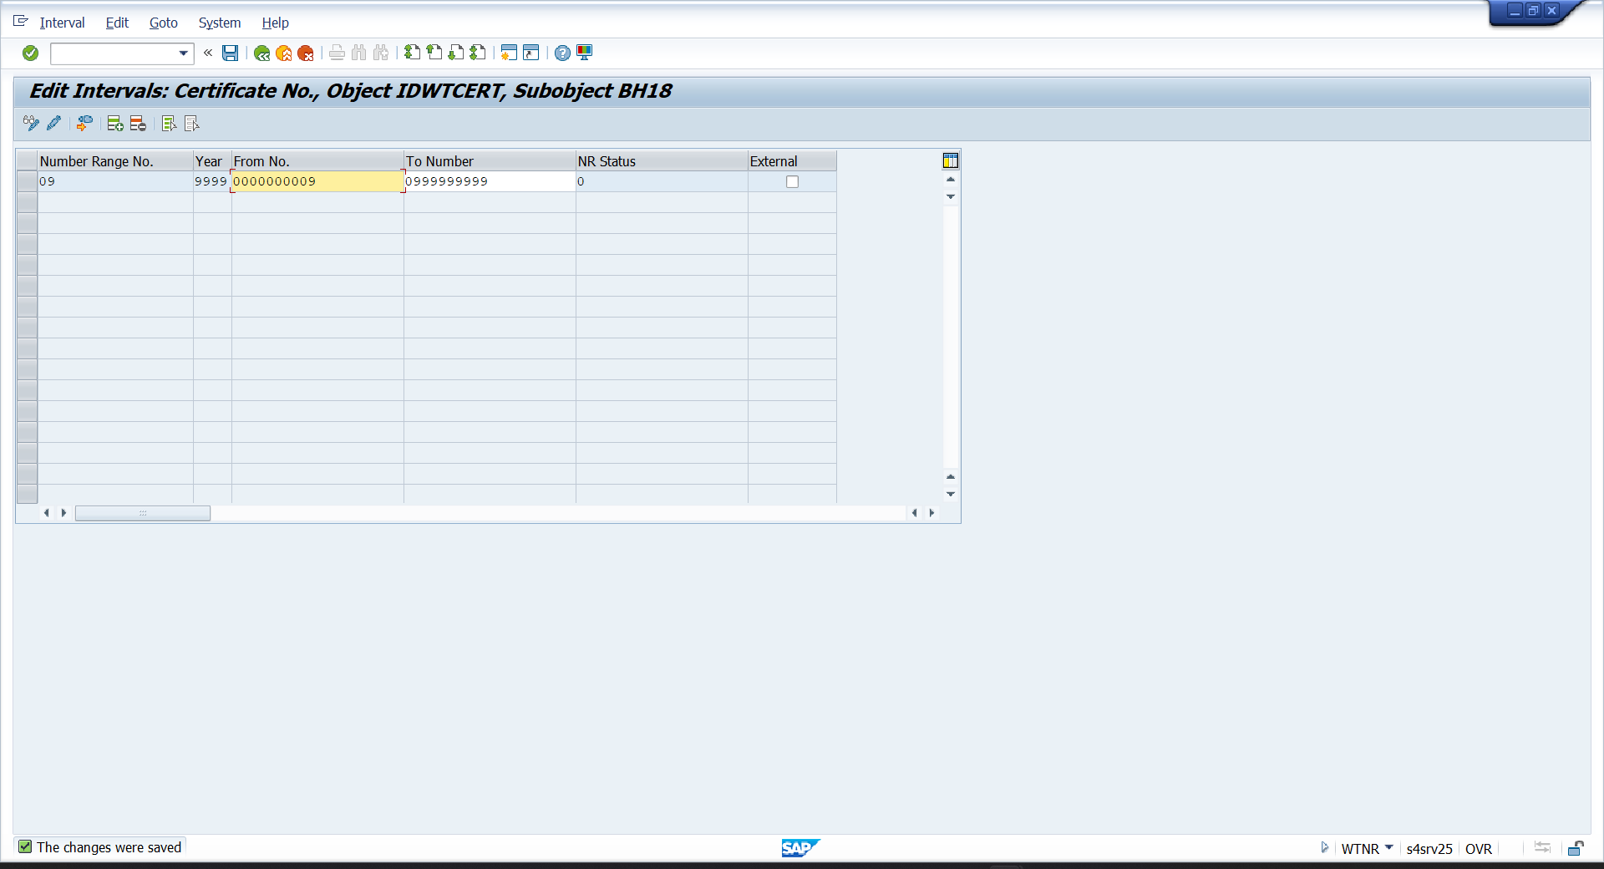

- SPRO—IMG—FINANCIAL ACCOUNTING—FINANCIAL ACCOUNTING FOR GLOBAL SETTING—WITHOILDING TAX—EXTENTED TAX—POSTING—INDIA— REMITTANCE CHALLANS—DOCUMENT TYPE—SPECIFY DOCUMENT TYPE (ACCOUNT PAYABLE)
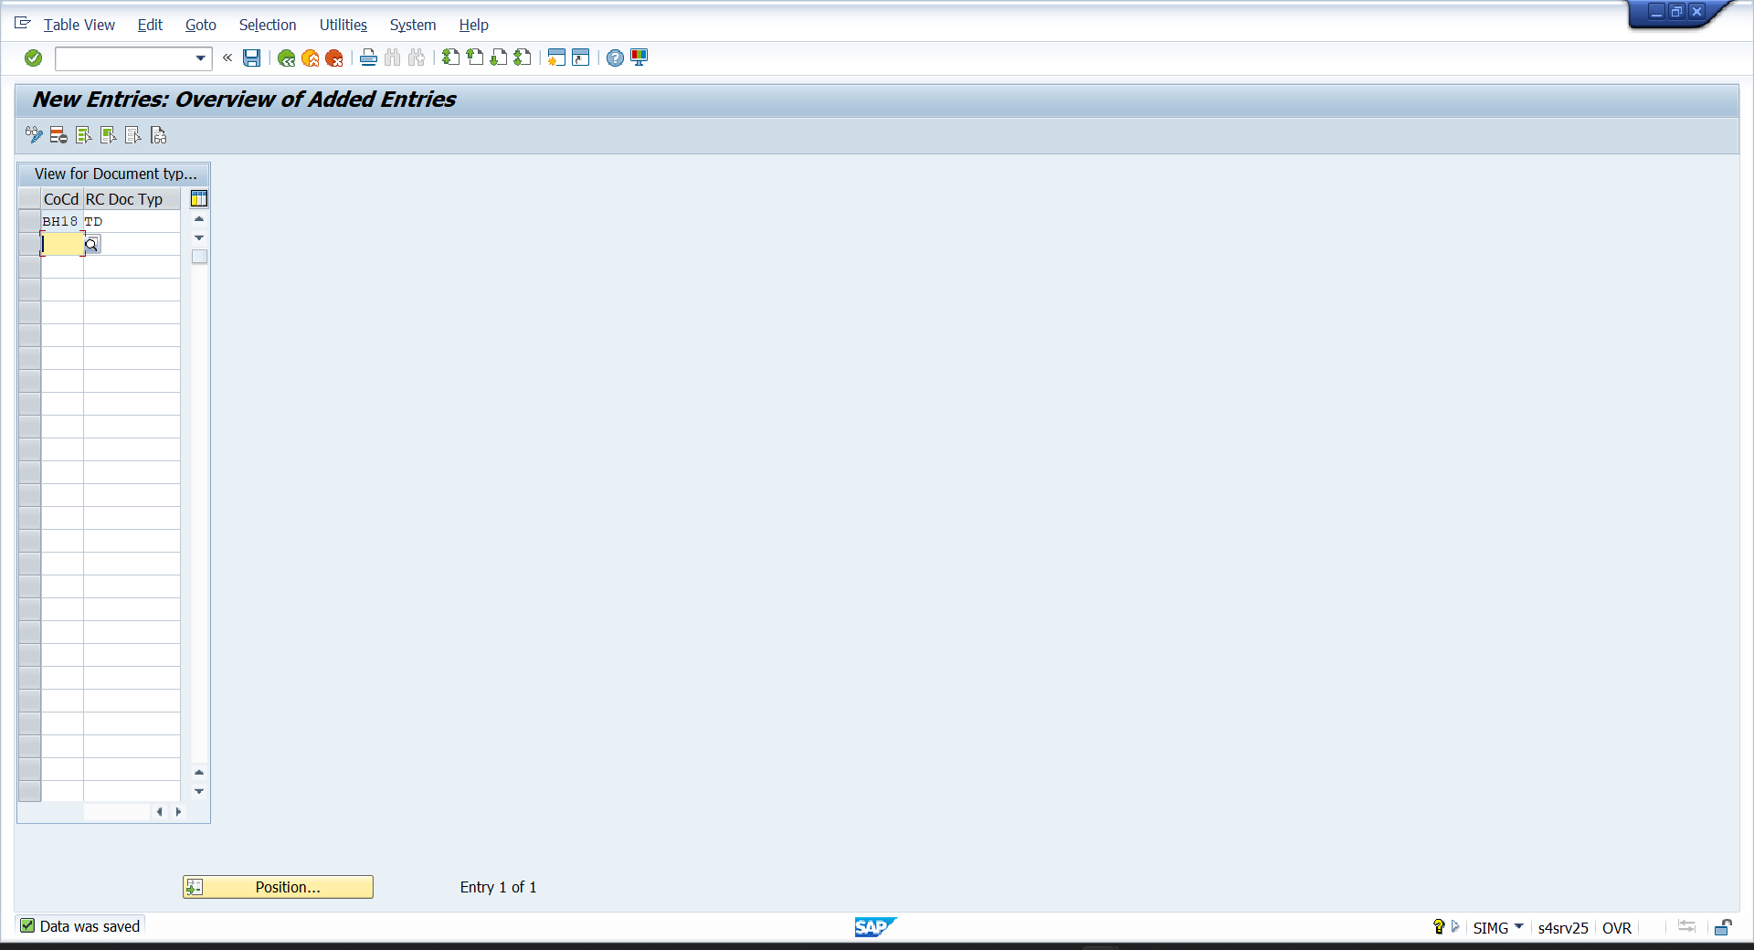

- SPRO—IMG—FINANCIAL ACCOUNTING—FINANCIAL ACCOUNTING FOR GLOBAL SETTING—WITHOILDING TAX—EXTENTED TAX—COMPANY CODE—ACTIVATE EXTENTED WITHHOLDING TAX
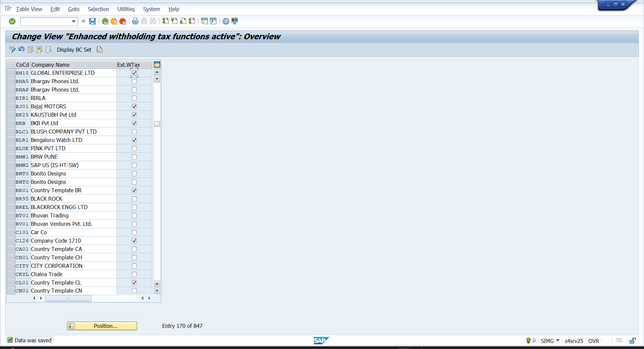

- BP
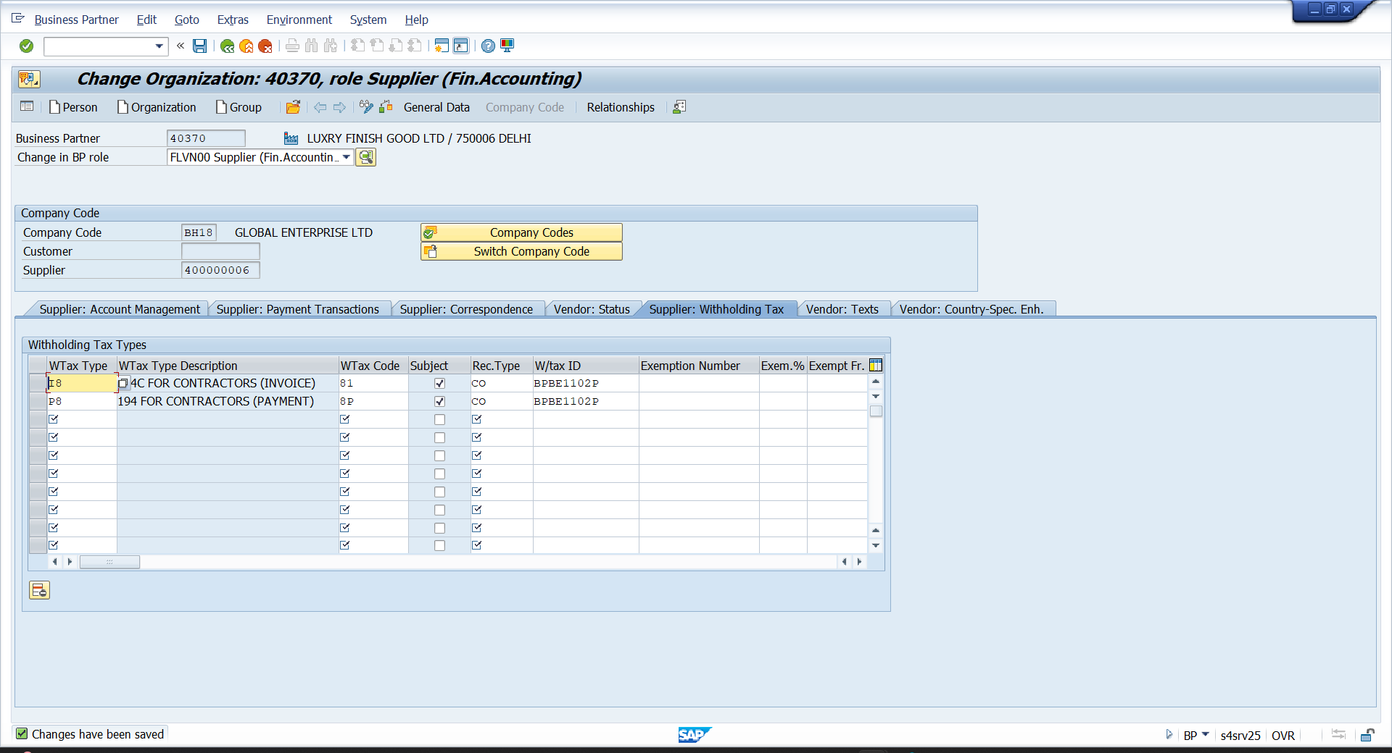

- FS00
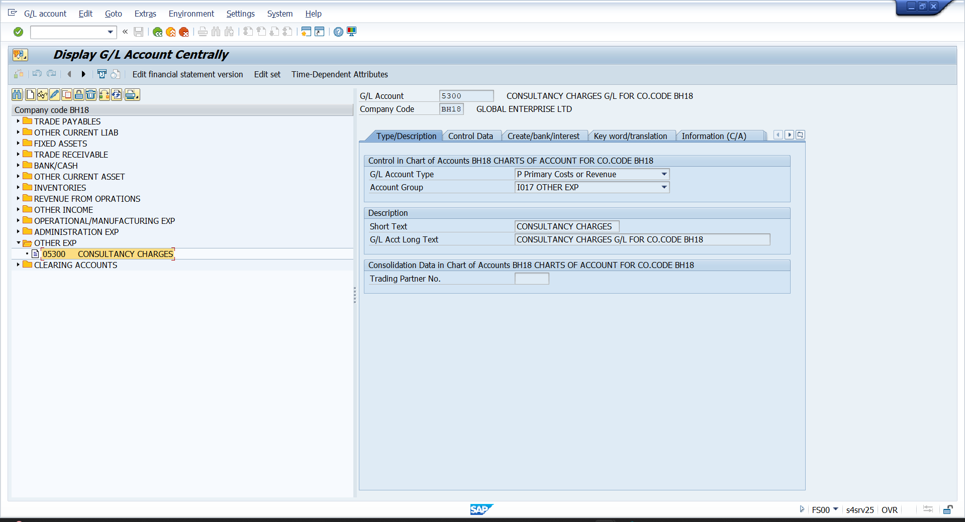

- FB60
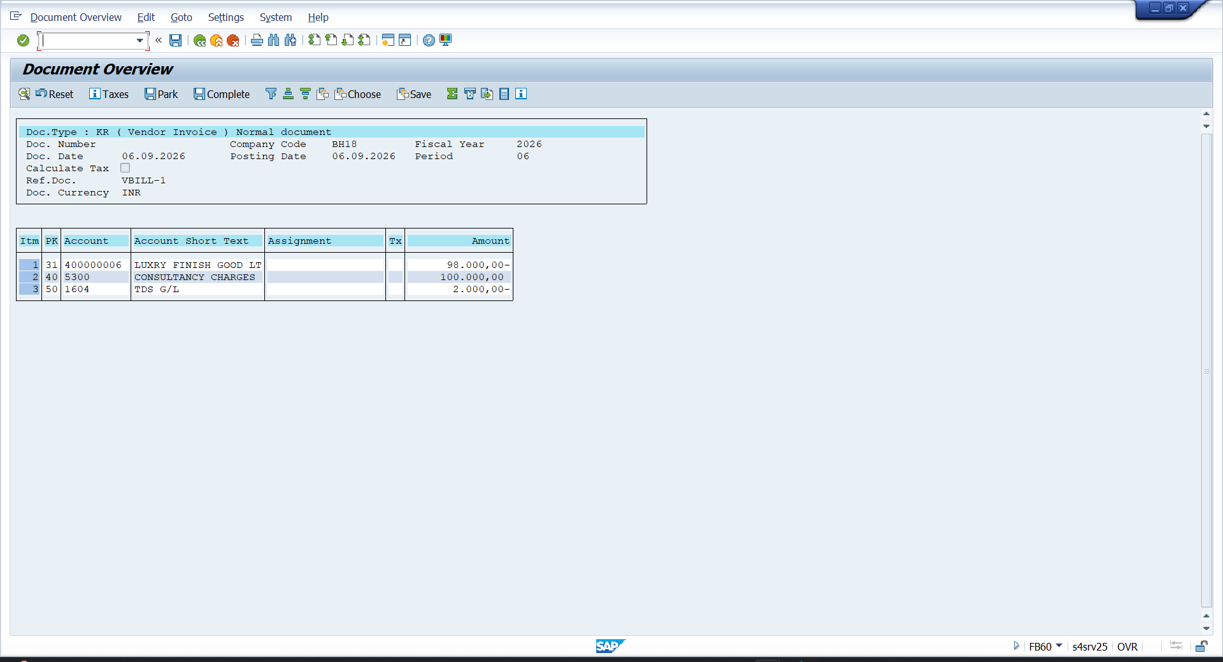

- F-53
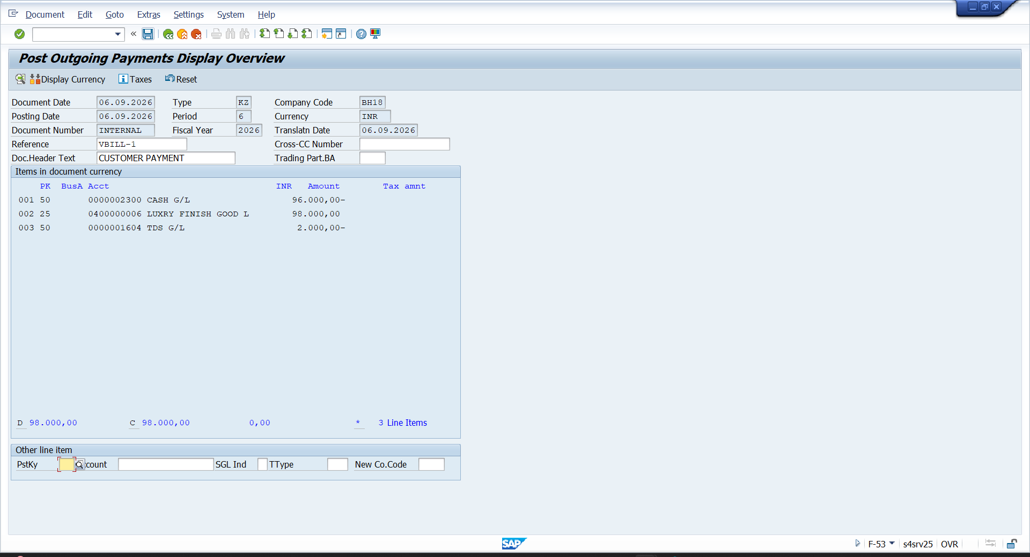

- FBL1N
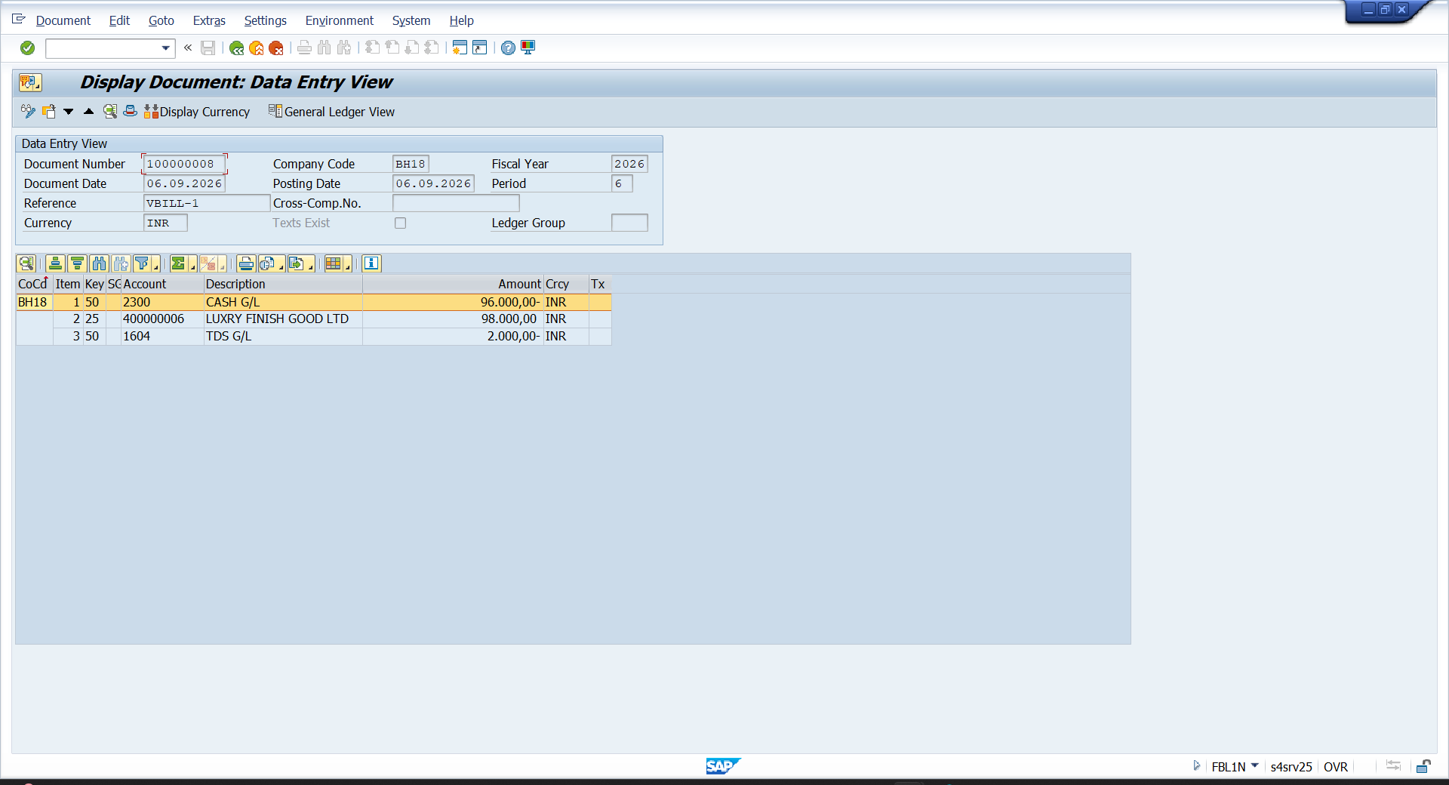

- FS00
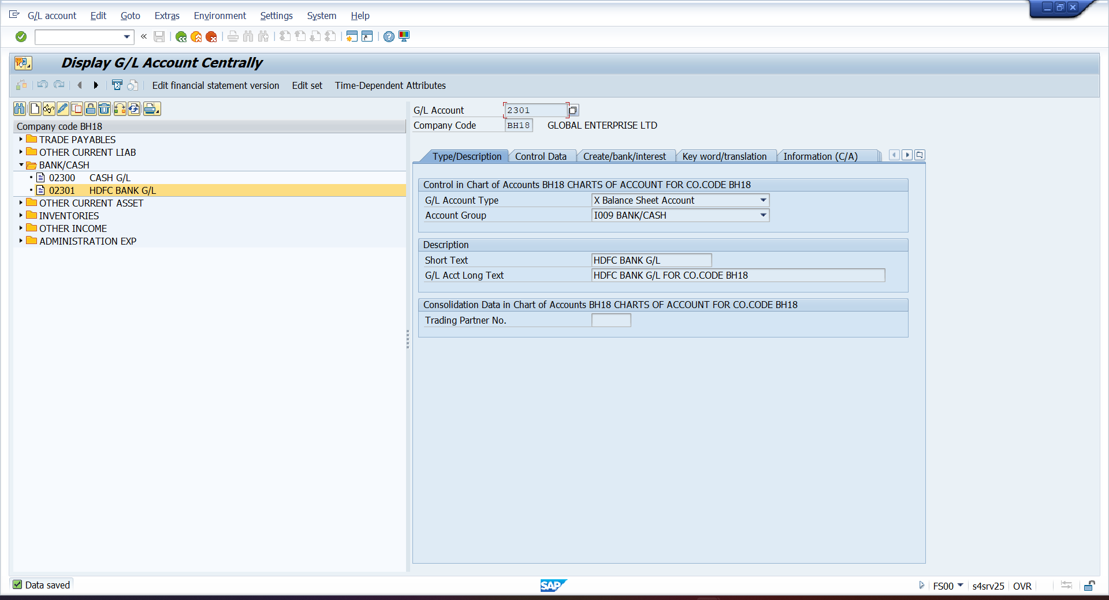

- FI12
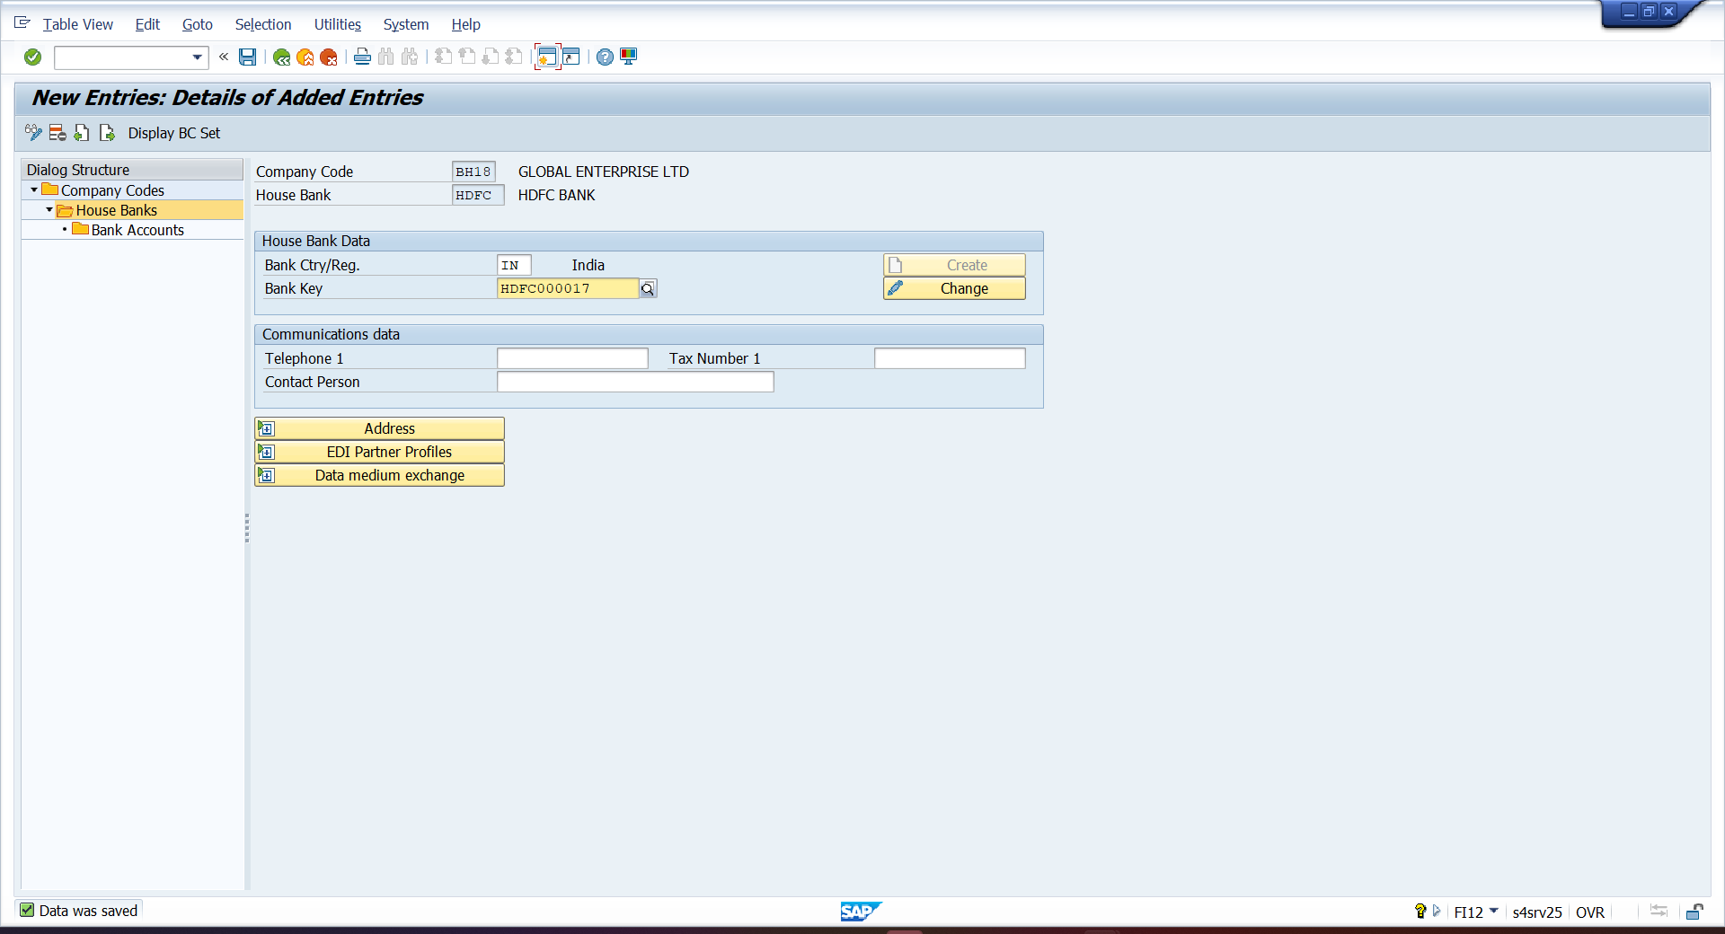

- SAP FIORI - /N/UI2/FLP
